Dear Mr/Mrs. Nejal,

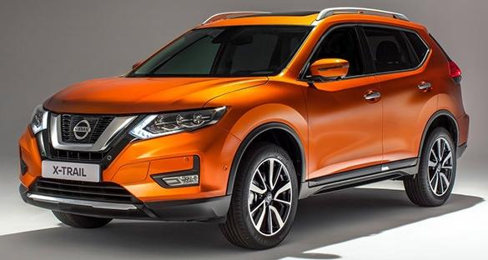
We are pleased to introduce to you the new NISSAN XTRAIL 2018. Nissan has recently updated its one of the flagship SUVs in the market by introducing 2018 version. The new X-Trail is now more aggressive and comes with an improved performance. It is also backed with the company’s new Intelligent Mobility package that features a range of driver assists and safety features.

In terms of design, the major changes have been done in the front and rear profile. The new V-Motion 2.0 grille in between sharp headlights reflects the aggressive characteristics of the SUV in an effective manner. This is further complemented by the reshaped front bumper and fog lamps. Focusing on the rear profile, the updated X-Trail has been treated with a lot of chrome work. In addition, the tail lights are now powered by LEDs. The top-end model further boasts an electric sunroof and 19-inch alloy wheels while the rest of the design language has been kept unchanged.

In the cabin, a lot improvement can be noticed. Starting with the leather covered steering design, it is now sporty and easy to use due to its nicely placed controls on it. The feel of the cabin is also improved with the inclusion of soft-touch materials on the dashboard and a new leather covering on the seats. The manufacturer has also added motion activated tailgate that allows a user to access the boot with ease.

In terms of powertrain, no major update has been done and the 2018 X-Trail carries the same engine options. First is the 2.0-litre unit that delivers 144 PS of maximum power and 200 Nm of peak torque. Whereas, the bigger option is a 2.5-litre mill that is rated at 171 PS of maximum power and 233 Nm of peak torque. The smaller engine comes with a two-wheel drive option while the all-wheel drive is coupled to the bigger mill. Both the engines come with Xtronic Continuously Variable Transmission.

Just like the outgoing model, the 2018 X-Trail will be also assembled in Japan and will be imported in the country.

The prices of the 2018 Nissan X-Trail are as follows:

X-Trail 2.0 4x2: Php 1,399,000.00
Discount: Php 10,000.00

FREEBIES : Standard tint
Floor matts
Seat cover
3 years LTO
3 years TPL
EWD

Prices are subject to change without prior notice; prices at the time of delivery shall therefore prevail.

All units are covered with three years warranty or 100,000km whichever comes first.

Thank you for giving us the opportunity of providing the above information. We look forward
to serving your vehicle requirement the soonest.

Sincerely,

Daryl de Lara
Nissan Sucat Parañaque
Nissan Marketing Professional
0916-5103946 / 0922-4748645

